Building and Securing a Network with a Demilitarized Zone

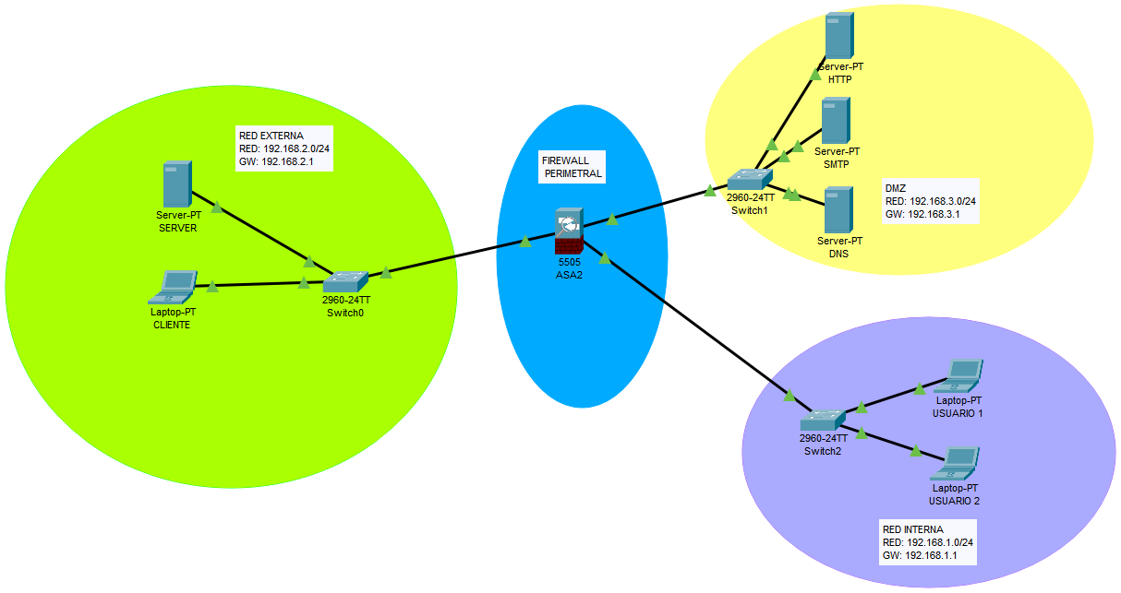
Network Design:

Firewall - 5505 ASA2
DMZ (Network)
- Switch 1 - 2960-24TT
- Server DNS
- Server SMTP
- Server HTTP
*Network: 192.168.3.0/24
*Default Gateway: 192.168.3.1

Internal (Network)
- Switch 2 - 2960-24TT
- Laptop 1
- Laptop 2
*Network: 192.168.1.0/24
*Default Gateway: 192.168.1.1
External (Network)
- Switch 0 - 2960-24TT
- Server
- Laptop
*Network: 192.168.2.0/24
*Default Gateway: 192.168.2.1
Firewall Configuration:
interface Vlan1
nameif inside
security-level 100
ip address 192.168.1.1 255.255.255.0
interface Vlan2
nameif outside
security-level 0
ip address 192.168.2.1 255.255.255.0
interface Vlan3
no forward interface Vlan1
nameif DMZ
security-level 50
ip address 192.168.3.1 255.255.255.0
access-list 101 extended permit tcp any host 192.168.3.2 eq www
access-list 101 extended permit udp any host 192.168.3.4 eq domain
access-list 102 extended permit tcp 192.168.1.0 255.255.255.0 host 192.168.3.4 eq smtp
access-list 102 extended deny tcp 192.168.1.0 255.255.255.0 host 192.168.3.2 eq www
access-list 102 extended deny tcp 192.168.1.0 255.255.255.0 host 192.168.3.3 eq domain
access-list 102 extended permit ip 192.168.1.0 255.255.255.0 any
access-group 101 in interface outside
access-group 102 in interface inside

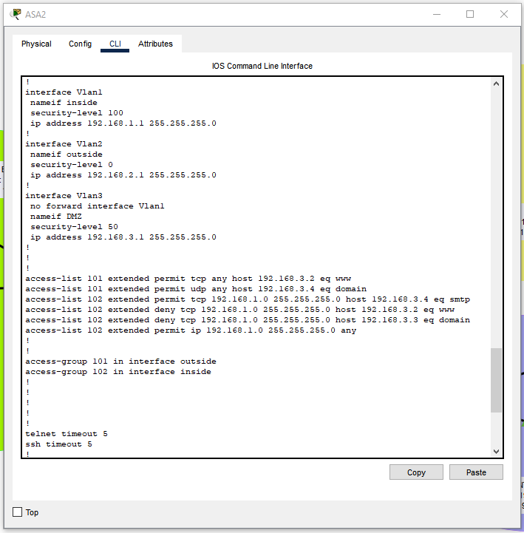
DMZ Setup:
Web Server:
Services: [HTTP] HTTP/HTTPS: ON
Default Gateway: 192.168.3.1
DNS Server: 192.168.3.4
Ipv4 Address: 192.168.3.5
Subnet Mask: 255.255.255.0
Mail Server
Services: [EMAIL] SMTP Service/POP3 Service: ON
Domain Name: 4geeks.mail.com
User: 4geeks
Password: 123456
Default Gateway: 192.168.3.1
DNS Server: 192.168.3.4
Ipv4 Address: 192.168.3.3
Subnet Mask: 255.255.255.0
DNS Server
Services: [DNS] DNS Service: ON
Name: 4geeks.com
Address: 192.168.3.2
Type: Record
Default Gateway: 192.168.3.1
DNS Server: 192.168.3.4
Ipv4 Address: 192.168.3.4
Subnet Mask: 255.255.255.0
Documentation:
* Vlan1 - Security-Level 100
- This is the highest security level.
- By default, this is assigned to the “inside” interface.
* Vlan2 - Security-Level 0
- This is the lowest security level.
- By default, it is assigned to the “outside” interface.

* Vlan3 - Security-Level 50
- Intermediate security level.
- Security level 50 is commonly assigned to interfaces like a DMZ, where public-facing servers (web, email, DNS, etc.) reside.
access-list 101 extended permit tcp any host 192.168.3.2 eq www
It allows any device to establish a TCP connection to 192.168.3.2 on port 80 (HTTP).
access-list 101 extended permit udp any host 192.168.3.4 eq domain
It allows any device to send UDP DNS queries to 192.168.3.4, specifically on port 53.
access-list 102 extended permit tcp 192.168.1.0 255.255.255.0 host 192.168.3.4 eq smtp
It permits TCP traffic from the internal network (192.168.1.0/24) to the SMTP server (192.168.3.4) on port 25.
access-list 102 extended deny tcp 192.168.1.0 255.255.255.0 host 192.168.3.2 eq www
It blocks internal users (192.168.1.0/24) from accessing the web server at 192.168.3.2 on port 80 (HTTP).
access-list 102 extended deny tcp 192.168.1.0 255.255.255.0 host 192.168.3.3 eq domain
It blocks TCP DNS traffic (port 53) from the internal network (192.168.1.0/24) to the DNS server at 192.168.3.3.
access-list 102 extended permit ip 192.168.1.0 255.255.255.0 any
It permits all IP-based traffic from the internal network (192.168.1.0/24) to go to any destination — including the DMZ, Internet, or other networks.
access-group 101 in interface outside
It enforces the rules defined in access-list 101 on all traffic coming into the firewall from the outside (e.g., the Internet).
access-group 102 in interface inside
It enforces the rules in access-list 102 on all traffic entering the ASA from the inside network.

